**POWERBI**

**TUTORIAL 1**

Step 1: Load the Superstore data.

A **parameter table** is used to allow users to select a value (like “Sales”, “Profit”, or “Quantity”) and dynamically update the measure displayed. Follow these steps to create it:

Step 2: Go to the **Modeling** tab and select **New Table**. Enter the following code to create a simple table with different metrics:

ParameterTable = {

        "Sales",

        "Profit",

        "Quantity",

        "Discount"

}

Step 3: After creating this table, go to the Report View. Drag it into a **slicer** visual in your report. This slicer will now act as the control for selecting which metric to display in your visualizations.

Step 4: Rename “Value” to “Make a selection”

Step 5: Now we will create a dynamic measure that changes based on the value selected in the slicer. Go to the **Modeling** tab and select **New Measure**. Enter the following DAX formula:

User Selection = SELECTEDVALUE(ParameterTable[Value])

Step 6: Create another **New Measure** by following DAX formula:

Calculation =

SWITCH(

TRUE(),

[User Selection]= "Sales", SUM(Orders[Sales]),

[User Selection]= "Profit", SUM(Orders[Profit]),

[User Selection]= "Quantity", SUM(Orders[Quantity]),

[User Selection]= "Discount", AVERAGE(Orders[Discount]),

"Select any single calculation"

)

This measure uses SWITCH to select the appropriate calculation based on the value in User Selection. When “Sales” is selected, it will sum up the Sales column; if “Profit” is selected, it will sum up the Profit column, and so on.

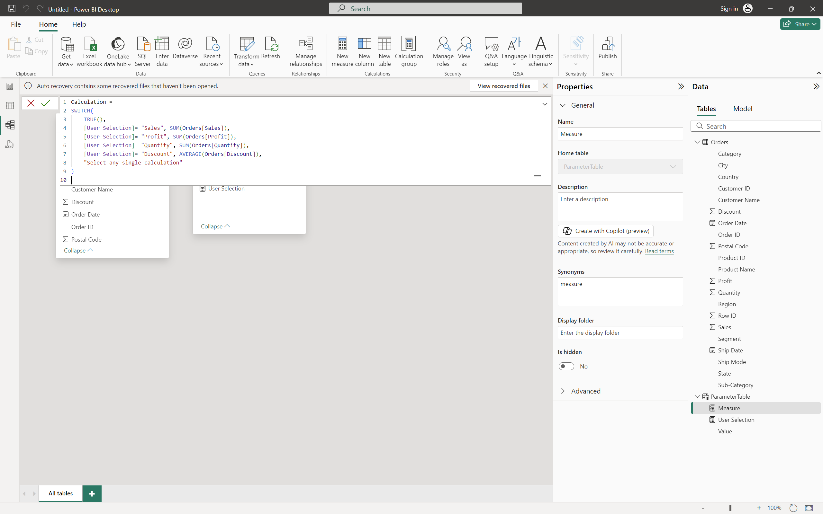

Step 7: Drag a card. Add **Parameter Table > Value** to Fields. Click on one of the slicer options to see the change on the card.

Step 8: Select table and drag Year and Month from Orders Table and Calculation from Parameter Table

Now, changing the value in the slicer will update the visuals dynamically.

Step 9: Select another table. Drag **Category** and **Sub-category** to the table.

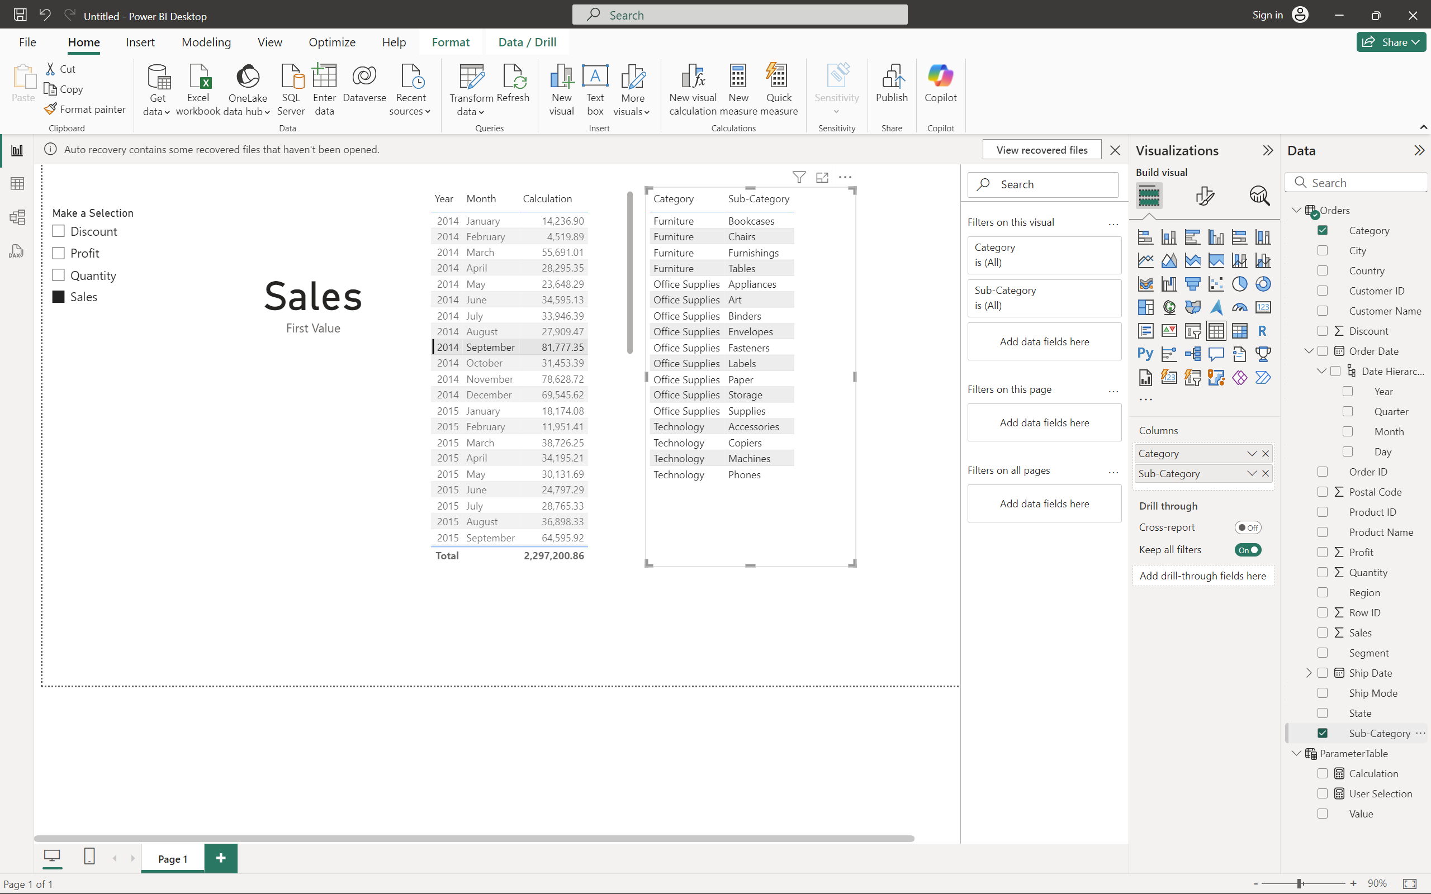

Step 8: Select a column chart. Drag **Category**, **Sub-category** and **Calculation** into the chart.

Now changing the selection in the slicer and selecting a category or sub-category will make changes in the table and bar plot.

**Question**

1. Implement a line chart showing the selected metric’s trend over time (by Year and Month).
2. Explore the patterns in Sales, Profit, and Quantity across different Sub-Categories over time. How do the trends shift when switching between these metrics? What insights can you gather regarding seasonal trends, high-performing categories, or products?
3. Explain how the SWITCH function in your DAX calculation enables dynamic switching between the metrics in the charts.

**Tutorial 2**

Step 1: Load the Superstore dataset.

Step 2:In the **Data View**, find columns such as **Country**, **State**, **City**, and **Postal Code**.Right-click on **Country**, select **New Hierarchy**. This will create the hierarchy.Add **State**, **City**, and **Postal Code** to this hierarchy by right-clicking on each of these columns and selecting **Add to Hierarchy** > **Country Hierarchy**.

Step 3: Go to **Report View**. In the **Visualizations Pane**, select the **Decomposition Tree** visual. Drag the newly created **Country Hierarchy** to the **Explain By** section of the Decomposition Tree. Drag **Sales** to the **Analyze** section.

Step 4:In the report, click on the + and select **Country** to drill down into the **Country**, followed by **State**, **Cities**, and then **Postal Codes**.As you drill down, the Decomposition Tree will show a breakdown of **Sales** by different geographical levels.

Step 5: Select a **Pie Chart** from the **Visualizations Pane**.Drag **Sales** to the **Values** field.Add **Country** **Hierarchy** to the **Legend** field.

Step 6: Successively clicking on the required State and City will give pie chart for that particular selection.

**Questions:**

1. **Extend the hierarchy** to include **Category**, **Sub-Category**, and **Product Name** from the **Superstore dataset**. Drill down from **Country** all the way to **Product Name** to view the sales performance by each product. What insights can you gather from the sales data at the product level?
2. Explore the **State** of **California** specifically and continue drilling down into **City**, **Postal Code**, and **Product Name**. Identify which products contribute the most to sales in **California**.
3. Using the pie chart, compare the total sales between two states of your choice (e.g., **New York** and **Texas**). How do the sales patterns differ between the two states across different product categories?
4. Add **Order Date** to the tree decomposition and analyze sales trends over time in a specific state (e.g., **Florida**). What are the high-performing quarters or months?

**Tutorial3:**

1. Download the Excel file titled "Industries Layoff Data" and import it into Power BI as demonstrated.

2. Choose the 'Stacked Column Chart' option from the visualizations panel.

3. Assign the **Industry** field to the X-axis, the **Laid_off** field to the Y-axis, and the **Year** field to the legend to display the layoffs by industry and year.

In the above, we have used stacked column chart to visualize the people laid off in various industries.

4. Add cards to display the **company size before layoffs and the company size after layoffs**.

5. Incorporate a map into the dashboard by selecting the **industry** and **country** attributes.

6. By selecting a specific industry, you can view the count of layoffs as well as the company size before and after the layoffs.

7. Now in the filters select only “India”, “United Kingdom” and “USA” under Country.

Select “Finance”, “Healthcare”, “Marketing” and “Security” under Industry.

You can modify the filters anytime by just selecting or unselecting them in the filters section.

**Observation: -** Based on the above graph we can see that HealthCare leads the number of layoffs in the industries we have selected.

**Question:**1. Apply the filter for **Country** and select only **USA**.

How does the number of layoffs in various industries change when focusing solely on USA? Which industry shows the most significant layoffs in 2024?

2. Apply filter to select only the **Healthcare** and **Marketing** industries.

What differences do you notice in the layoff counts between these two industries? Which industry appears to have a higher impact on layoffs?

3. Apply filters for **Country** (select **India**, **USA**) and **Industry** (select **Finance** and **Security**).

How do the layoffs in Finance and Security compare in the selected countries? Are there notable differences in the company sizes before and after layoffs in these sectors?

4.Expalin your understanding of the task.